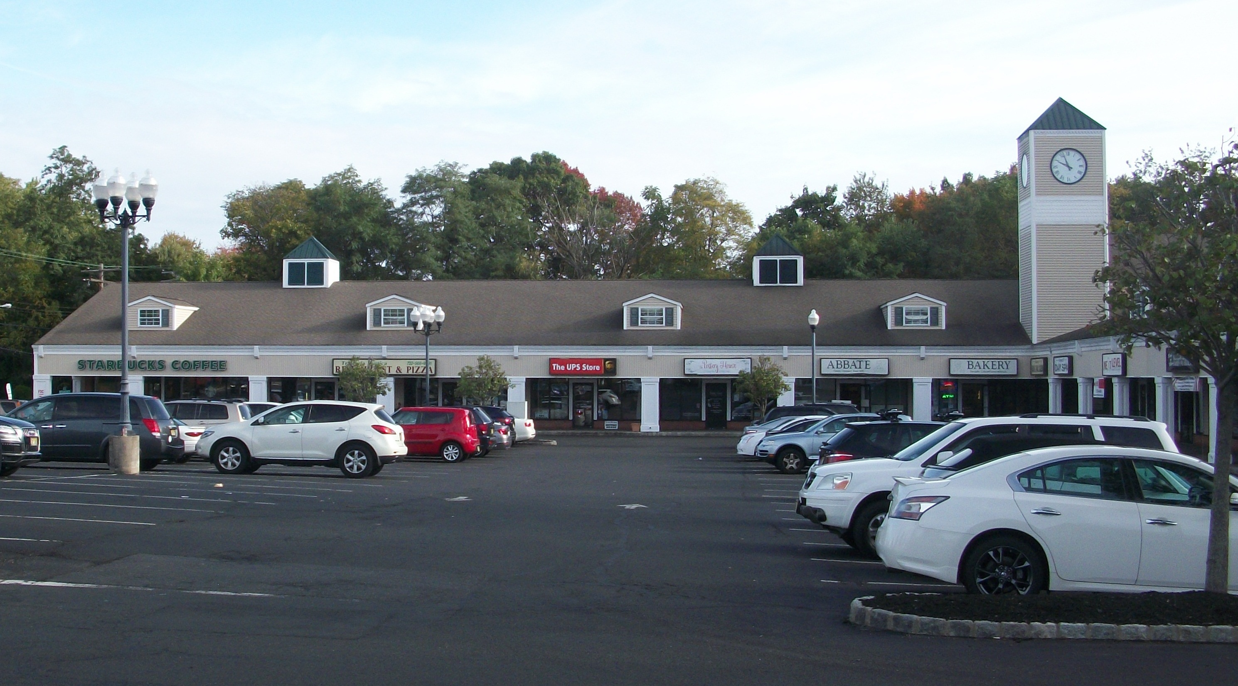
ADDRESS: 265 Main Street, Matawan NJ
DESCRIPTION: LOCATION, LOCATION, LOCATION! Main Street Village retail space now available for lease.
1,200 - 3,600 (+-) square foot retail spaces located in a strip center located at the intersection of Route 34 and Main Street with easy access and exit from all directions. 200 parking spaces shared with neighboring tenants such as Starbucks, Jersey Mikes, UPS Store, 25 Burgers and Sun Bank.
ZONING: Highway Improvement District. Permitted uses include retail, credit agencies, insurance offices, medical and health services, accounting, dance studios, schools, legal services, engineering and architectural services.
RENT: $23 per square foot NNN

